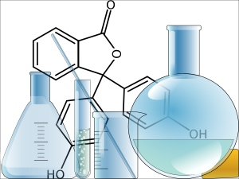
Title: * a brief, concise, yet descriptive title
Aim:
- State the purpose of the experiment.
- What question(s) are you trying to answer?
- Include any preliminary observations or
background information about the subject
Hypothesis:
- Write a possible solution for the problem.
- Make sure this possible solution is a complete sentence.
- Make sure the statement is testable, an ‘if-then statement’ is recommended to illustrate what criteria will support your hypothesis (and what data would not support the hypothesis).
- State reasons to justify your hypothesis.
Materials:
- Make a list of ALL items used in the lab.
Procedure:
- Write a paragraph (complete sentences) which explains what you did in the lab as a short summary.
- Add details (step-by-step) of your procedure in such a way that anyone else could repeat the experiment.
Results (Data):
- This section should include any data tables, observations, or additional notes you make during the lab.
- You may attach a separate sheet(s) if necessary.
- All tables, graphs and charts should be labelled appropriately.
Discussion:
- Include a summary of the data – trends, averages, highest, lowest etc to help the reader understand your results. Try not to copy your data here, you should summarize and reference KEY information.
- List one thing you learned and describe how it applies to a real-life situation.
- Discuss possible errors that could have occurred in the collection of the data (experimental errors)
Conclusions:
- Accept or reject your hypothesis.
- EXPLAIN why you accepted or rejected your hypothesis using the experimental data.

