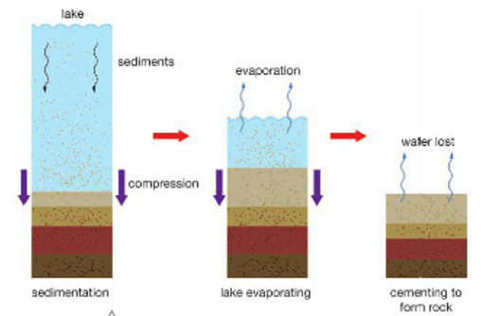
Sedimentary rocks are rocks composed of sediments
that are cemented together. They are classified by the
type of sediment.
There are three basic types of sediment:
- Weathered Rock Sediments
Sedimentary rocks formed from weathered rock
are known as clastic sedimentary rocks. They contain:
Fossils - The preserved remains of organisms
that were once living.
Natural cements - Chemicals that can flow around
the sediments and then set like cement.
E.g. calcium carbonate (calcite), silica, quartz, iron oxide and clay minerals
- Chemical Sediments
Chemical sedimentary rocks form when materials dissolved in water come out of solution, form a rock. The process is crystallisation, in which the dissolved minerals turn into solid crystals as the water evaporates.
- Organic Sediments
Organic sedimentary rocks form when dead plant or animal matter accumulates and is cemented together.
Characteristics of Sedimentary Rocks
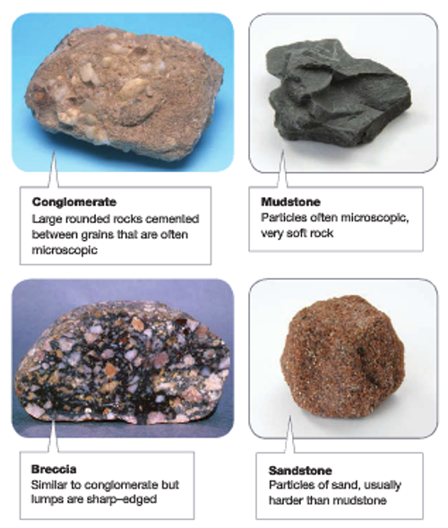
There are three different types of sedimentary rocks. Their characteristics depend on how they are formed.
- Clastic
- They form layers as sediments build up
- The grains are cemented together
- They may contain fossils
- They are classified according to grain size
and chemical composition of the cement.
- Chemical
- Most chemical sedimentary rocks have crystals
- Are quite soft compared with igneous rocks
- Generally do not show layering
- Occasionally contain fossils
- Organic
- Can be layered depending on how the fossils
and sediments are deposited
- They are usually soft although a few such as
Chert (also called flint) can be fairly hard
Uses of Sedimentary Rocks
Sedimentary rocks are widely used for building, paving
road base, foundations and wall construction. In industry, sedimentary rock is used in many ways:

- Limestone - making cement, glass and steel
- Sandstone - making glass
- Gypsum - making plaster
- Rock Phosphate - making phosphate fertiliser
- Coal - used for energy supply
- Used as a source of minerals:
Haematite - source of iron
Bauxite - source of aluminium

