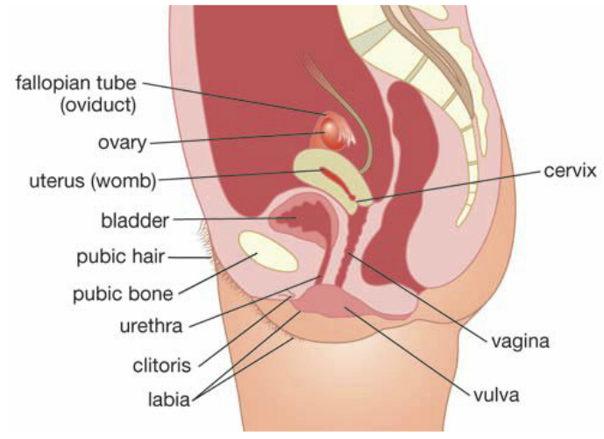
The human reproductive system enables us to produce offspring. Chemicals from your reproductive organs affect your behaviour, the way you grow, your appearance and how your body works.
The Female Reproductive system
The female reproductive system Has a role of producing a baby.
The function of the parts in the diagram are summarised below:
- Ovaries - The eggs (or ova) are produced in the ovaries.
Usually only one egg forms the follicle each month.
- Fallopian Tubes - Tubes that transfer the egg to the uterus after ovulation.
This is the site of fertilisation of an egg by a sperm.
- Uterus - A thick-walled muscular organ where the baby grows and develops.
The fertilised egg burrowing into the endometrium is called implantation.
- Cervix - A muscular ring at the lower part of the uterus that contracts tightly
to hold the uterus closed while the baby develops.
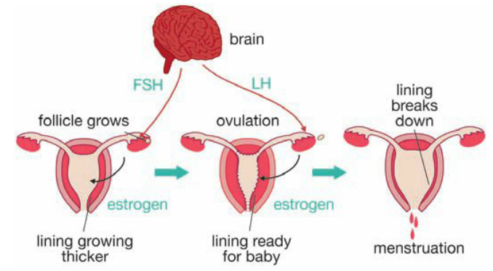
- Vagina - Allows the male penis to be inserted to deposit the sperm inside
the female body. It is also the birth canal for the baby.
The Menstrual Cycle
The changes that occur in the female reproductive system over a
month are called the menstral cycle. These changes are controlled
by chemicals called hormones that change their amount in the body
over a month. This is a summary of the three main hormones:
- FSH (folicle stimulating hormone)
- Causes the folicles in the ovary to mature.
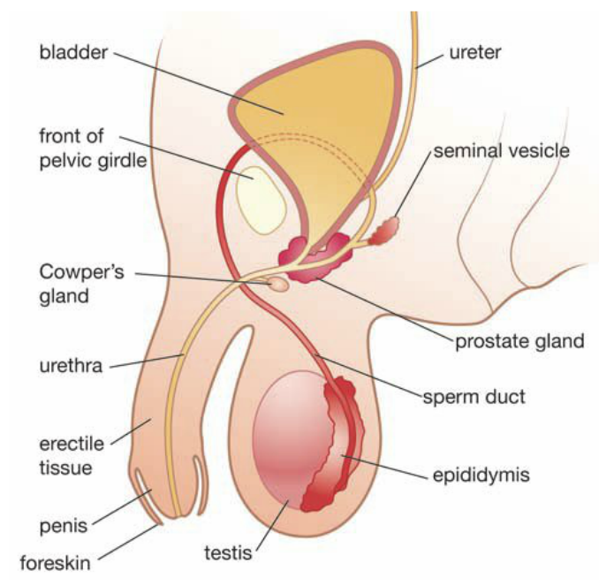
- LH (leutenising hormone)
- Makes the egg burst out of the folicle. This is called ovulation.
- Estrogen
- Makes the lining of the uterus grow thicker and develop an
increased blood supply If the egg is not fertilised and implanted,
the thichened lining of the uterus dreaks down during menstruation.
The Male Reproductive System
The role of the male reproductive system is to produce and deliver sperm.
The main parts are shown in the diagram:
- Testes - Hang in the scrotum to produce sperm at lower temperatures.
- Epididymis - Stores sperm until it matures.
- Vas deferens - Transfers semen (fluid and sperm) to the urethra
in the penis during ejaculation.
Puberty
Puberty refers to the time in a person’s life when they become able to reproduce. Puberty involves physical changes that bring sexual maturity. Girls begin puberty on average around 12 years of age, while boys are generally around 13.
- Changes in Males - enlargement of the testes, sperm formation of the testes, growth of the penis, voice ‘breaking’, hair growth on face, arms, chest and groin, increased muscle and bone growth and strength, increased height.
- Changes in Females - breasts begin to enlarge, hair growth on armpits and groin, sudden growth spurt, first period, widening of the hips, more fat deposited in the hips.

