**[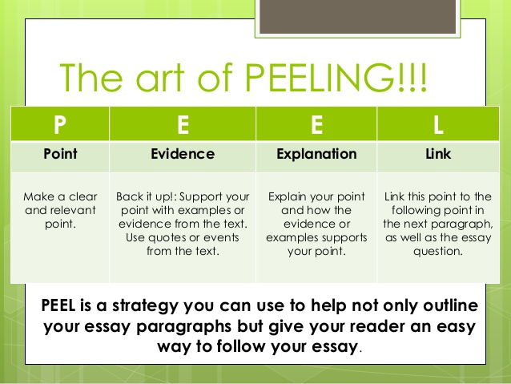](http://www.google.com.au/url?sa=i&rct=j&q=&esrc=s&source=images&cd=&cad=rja&uact=8&ved=0CAcQjRxqFQoTCJfn3dezg8cCFUwXlAodQtYIGA&url=http://www.slideshare.net/meghanlouisefennessy/peel-essay-writing&ei=EmK6VZeWIcyu0ATCrKPAAQ&bvm=bv.99028883,d.dGo&psig=AFQjCNFKMnIfEvpUZecNOQP5KZ6tn1sm7g&ust=1438364359079202)**

**Example:**

**[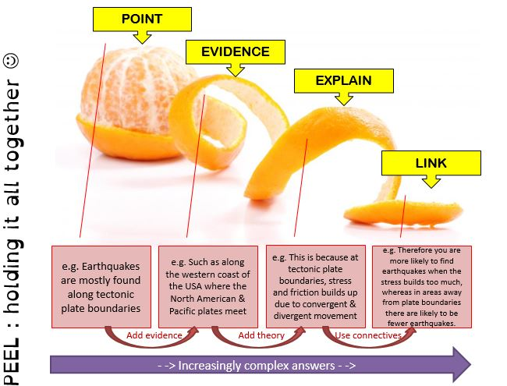](https://www.google.com.au/url?sa=i&rct=j&q=&esrc=s&source=images&cd=&cad=rja&uact=8&ved=0CAcQjRxqFQoTCNKnjsm1g8cCFYmelAodKDkKGw&url=https://jodebens.wordpress.com/tag/literacy/&ei=DGS6VdLxLYm90gSo8qjYAQ&bvm=bv.99028883,d.dGo&psig=AFQjCNFKMnIfEvpUZecNOQP5KZ6tn1sm7g&ust=1438364359079202)**