A nucleus is a cluster of protons and neutrons at the centre of an atom, surrounded by a cloud of electrons. The protons and neutrons are constantly moving, vibrating, and rearranging, causing some to emit electromagnetic radiation called gamma rays. Occasionally, some nuclei also eject particles at high speed. This emission of electromagnetic radiation or particles is known as a nuclear reaction or nuclear decay.
During nuclear decay, atoms may undergo a transmutation and change from one element to another.
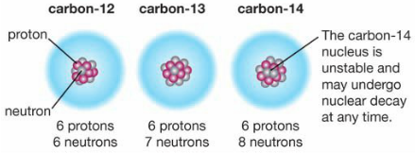
Radioisotopes
Most atoms contain stable nuclei. Each element may have several isotopes (atoms with the same number of protons but a different number of neutrons) - A tiny fraction of these isotopes have unstable nuclei and are known as radioisotopes. For example, carbon has three naturally occurring isotopes:
carbon-12, carbon-13, carbon-14
They are all types of carbon atoms because they all contain 6 protons.
As the number of neutrons increase, the nucleus becomes unstable.
carbon-14 is a radioisotope because it has 8 protons.
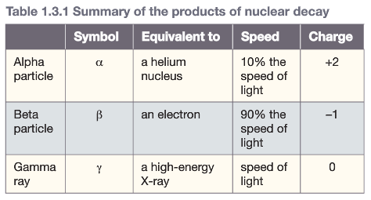
Types of Nuclear Decay
- Alpha Decay
During alpha decay the nucleus emits an alpha particle
which is a cluster of 2 protons and 2 neutrons
- Beta Decay
During beta decay the nucleus ejects a beta particle.
A neutron is converted into a proton & mass is unchanged.
- Gamma Decay
A form of electromagnetic wave similar to X-rays.
Half-life Carbon Dating
The rate at which nuclear decay occurs is measured by a Carbon dating relies on the fact that all living things contain
radioisotope’s half-life. The half-life of a radioisotope is a small amount of carbon-14, which remains constant over
the time it takes for half of the nuclei to decay. the life of an organism. When it dies carbon-14 is no longer
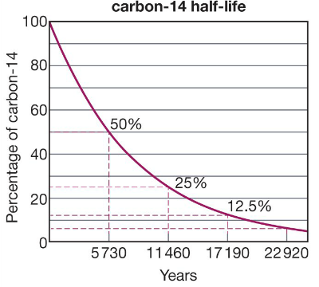
For example: The radioisotope radon-222 decays absorbed and begins to decay into nitrogen-14 as shown.
into polonium-218 with a half-life of 4 days.
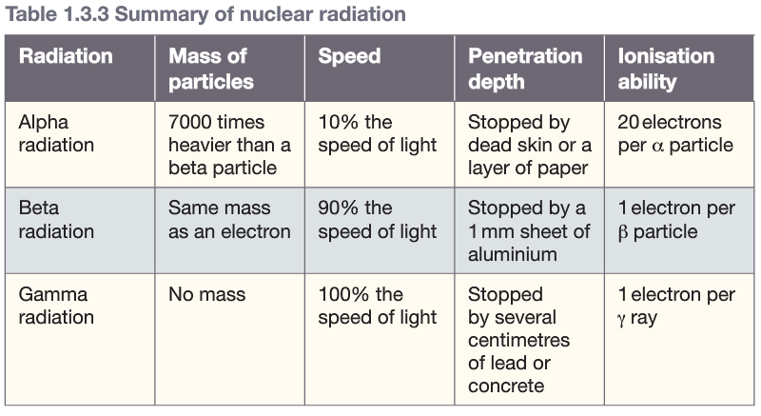
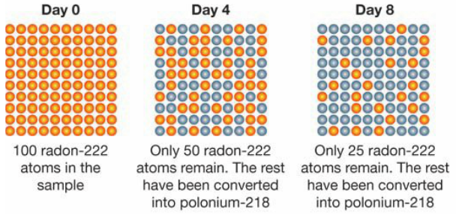
Carbon-14 has a
half-life of 5730 yrs.
By measuring the
amount of carbon-14
remaining, scientists
can determine the
number of half-lives
that have elapsed
since the organism died.
Biological Effects of Radiation
Alpha & beta particles and gamma rays are called ionising
radiation because they can remove electrons from atoms
and molecules. Exposing cells to ionising radiation destroys
biological molecules and can cause cells to die or mutate.
- Cell Death causes radiation burns & radiation sickness
- Cell Mutation causes cancer & genetic deformities
Dose - Whether exposure to radiation is harmful depends on
the type of radiation and the amount of radiation (dose)

