Cells are the building blocks of all living things. They are composed of smaller parts called organelles and each has its own specific function. These are described below. The diagram shows a typical animal cell.
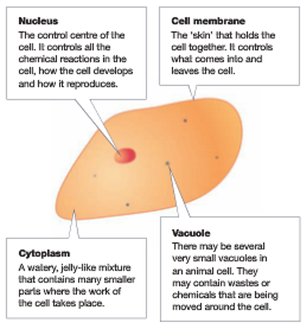
- Mitochondria Typical Animal Cell
Mitochondria are the powerhouse of the cell, which
release energy from food.
- Ribosomes
Ribosomes are microscopic factories that produce the
proteins used by the body for growth and repair.
- Lysosomes
Lysosomes are the garbage disposal units that get rid
of the wastes from the cell.
- Endoplasmic Reticulum
Endoplasmic reticulum form pathways that allow
materials to move quickly and easily through the cell.

Plant Cells
Plants have the same parts as animal cells plus a few extra parts.
The diagram shows a typical plant cell. Like animal cells, plant
cells have a cell membrane, cytoplasm and a nucleus.
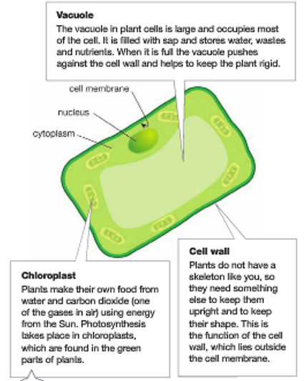
Typical Plant Cell
The vacuole in plant cells is much larger than in animal cells.
Plant cells also have the following organelles:
- Cell Wall
The cell wall helps support the plant and gives it shape.
- Chloroplasts
Chloroplasts contain chlorophyll and are the site
of photosynthesis.
Fungal Cells
Cells of fungi have the same cells as animal cells.

Fungal cells have a cell wall like plant cells but don’t have
chloroplasts and therefore cannot make their own food. Fungi
digest the material they grow on and absorb it into their cells.

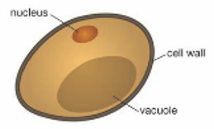
Typical Fungal Cell

