Classification is the process of putting things into groups. Sorting things this way makes it easier to find a particular item.
Which Group?
The group things are placed in depends on the reason for the grouping. They can be in different groups at different times. Plants and animals are often grouped in different ways. For example, grass in a lawn is encouraged to grow, but in a flower bed it is considered a weed – Whether a plant is classified as wanted or a weed depends on the situation.
Scientists Classify
Classification is used in all branches of science. Scientists group objects together based on similarities and differences:
- Chemists group substances according to their characteristics E.g. metal or non-metal, acid or base.
- Geologists classify rocks as sedimentary, igneous or metamorphic.
- Astronomers classify heavenly bodies as stars and planets.
Introducing Keys
Biologists classify living things. The science of grouping and naming things is called taxonomy. Once the characteristics of organisms are described this information can be used to develop a key, which is used to identify unknown organisms.
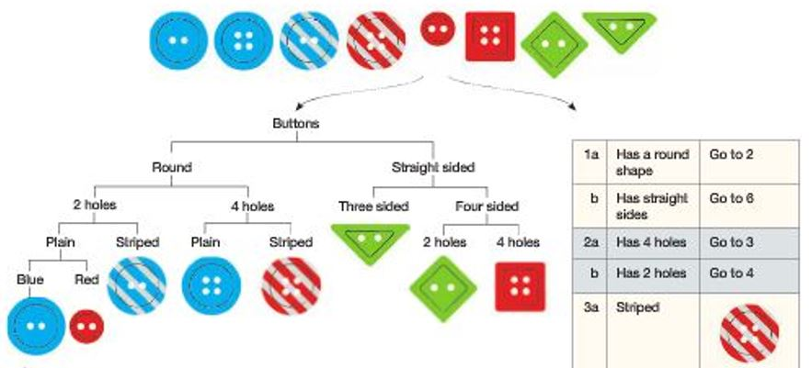
The simplest type of key is a dichotomous key which is a series of choices that leads to the identification of an object. At each stage there are two choices. This continues until there are no more choice and the object is identified. Keys work best if the features used to make the choices are easy to observe and are not subjective. Structural features make a much stronger key that can be used at any time, regardless of age of the organism. Keys can be drawn as flow charts or tables as shown below:

