Gravity
Around every mass is a gravitational force field that attracts other masses.
Gravity - A non-contact force that attempts to pull masses together.
Matter - Anything that has mass and takes up space.
Weight - The force of gravity acting on a mass that causes it to be attracted to the centre of the earth.
Factors Affecting Gravitational Fields:
- Mass - The bigger the mass, the stronger its gravitational field. Gravity acts on all objects but is only
noticeable hen one of the object is really massive. E.g. Planet, moon or star.
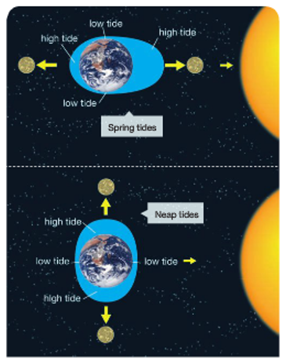
- Distance - The gravitational fields around planets, moons and stars rapidly gets weaker as you move
further away from them.
Tides
Tides are caused by the gravitational pull of the moon which drags
the water in oceans and seas towards it.
- This causes a bulge on the side of the earth that faces the
moon and another smaller bulge on the opposite side of
the earth. The sun also draws water towards it and changes
the size of the bulge.
- As the earth rotates this bulge moves, so that it stays
pointing towards the moon.
- These bulges cause two high tides and two low tides per day
as shown in the diagram.
- Spring tides are large because the gravitational pull of both
the Moon and the Sun are in the same direction.
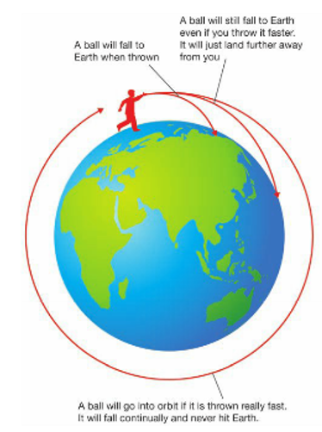
- Neap tides are smaller because the Moon and the Sun are
pulling in different directions.
Orbits
The gravitational fields of planets, moons and stars cause other masses
to travel continuously around them in a path known as an orbit.
- The diagram shows that the Earth orbits the Sun, and the Moon
orbits the Earth.
- Objects that are in orbits like this are known as satellites:
Natural Satellites - The Moon and planets of the solar system.
Artificial satellites - Man-made satellites orbiting the Earth.
- Orbits are elliptical (oval) in shape, but some are almost circular.
- Satellites stay in orbit because they move so fast that they keep
falling around the Earth, and there is no atmosphere in space
to slow them down.

Eclipses
An eclipse occurs when the Earth, Moon and the sun are aligned in the following ways:
- Solar Eclipse - The Moon blocks sunlight to the Earth’s surface, producing a complete or partial shadow.
- Lunar Eclipse - The Earth blocks sunlight from reaching the Moon, as shown below.
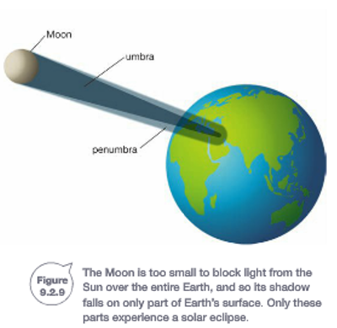
Solar Eclipse: Lunar Eclipse:
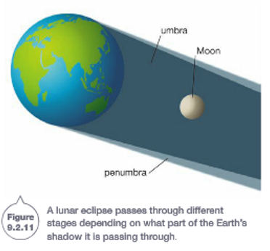

Phases of the Moon
The different shapes of the Moon that are visible from Earth are known as phases of the Moon. What we see depends on where the moon is in its orbit, and how much of the face is receiving sunlight. This is shown in the diagram below.
