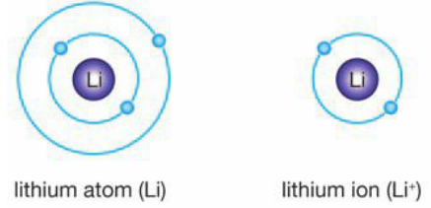
Atoms are electrically neutral because they contain an equal number of positive protons and negative electrons. However, if an electron is removed or added, the atom becomes charged and is now called an ion.
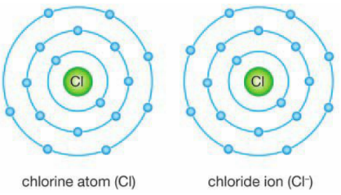
Cations are formed when an atom loses electrons and becomes positively charged.
Atoms tend to lose electrons if the outermost electron shell is mostly empty. The
atom will lose all the electrons in the outermost shell so that only filled shells remain.
Metals form cations since they have few electrons with weal attractions in the outer shell.
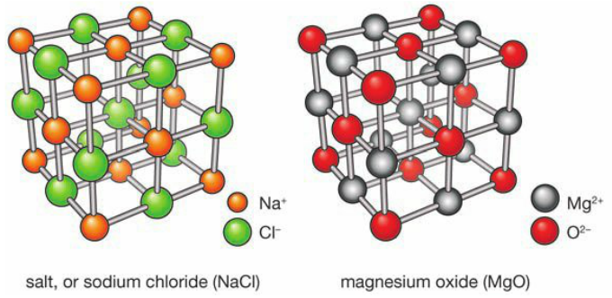
Anions are formed when an atom gains electrons and becomes negatively charged.
This will occur if the outermost electron shell is almost full. The atom gains electrons
until the shell is filled. All anions come from non-metallic atoms.
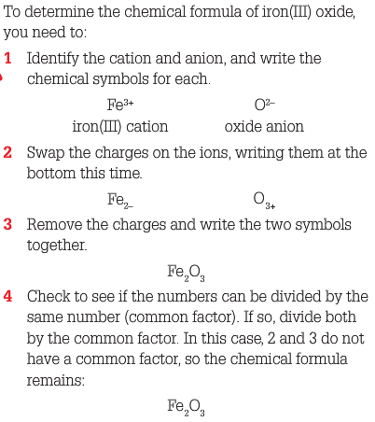
Ionic Compounds
When anions and cations combine, they
form compounds composed of large To name an ionic compound,
crystal lattices called ionic compounds. write the name of the cation
Examples are shown in the diagrams. followed by the anion.
The chemical formula must have
Ionic Bonding an equal number of positive and In ionic compounds, the ions are held together by negative charges = zero charge.
the electrostatic attraction of their opposite charges.
This electrostatic attraction is called an ionic bond. Writing Ionic Formulas
Ionic bonds holding crystal lattices together are very
strong. Therefore, ionic compounds are usually:
- Hard because it takes a lot of force to break the ionic bond.
- Brittle because the ionic bonds hold the in fixed positions.
- Have high melting points because high temperatures are required
to break the strong ionic bonds and allow the ions to flow freely.
Ions in solution
How easily an ionic compound dissolves in water is known as its solubility.
Soluble ionic compounds dissolve in water. Insoluble compounds do not.
When an ionic compound dissolves in water, the water particles surround
the ions. This breaks the crystal lattice apart and prevents the ions from
re-combining. If water is remove the ions stick together and recrystallise.
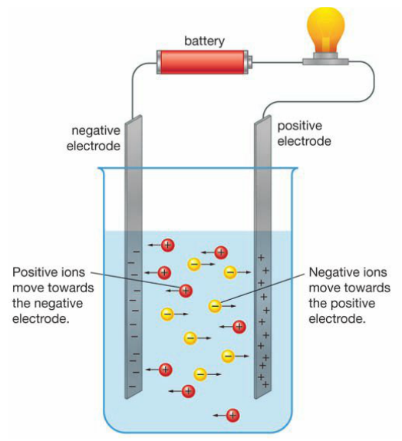
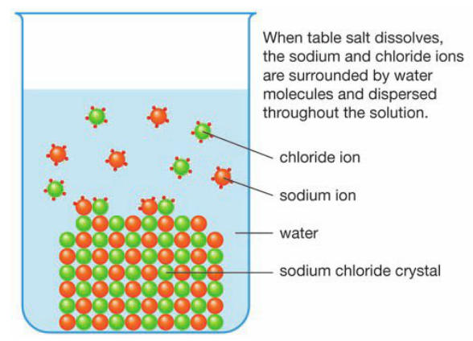
A Solution of Table Salt in Water Electrical Conductivity of Ions
When ions are in solution they can move freely. This creates a flow of electrical charge and therefore they conduct electricity.

