Nanotechnology is the study of how to produce and control tiny structures. The size of these structures is measured in nanometres (unit symbol nm). A nanometre is one-billionth of a metre; about 10 atoms could fit across it.
Dirt sits on top of a rough, hydrophobic (water-hating) surface.
Surface does not hold the dirt strongly, so it is picked up by the water and washed away.
Self-cleaning Paint
Lotusan is a self-cleaning paint that mimics
the rough surface of the lotus leaf. Water on
it forms near-spherical drops which then roll
across the surface, picking up and washing away dirt.
This is because the roughness of the lotus leaf makes
the surface ‘super-hydrophobic’ which does not allow
water to stick to it - as illustrated in the diagram.
Self-Cleaning Glass
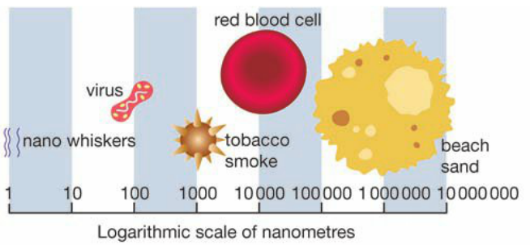
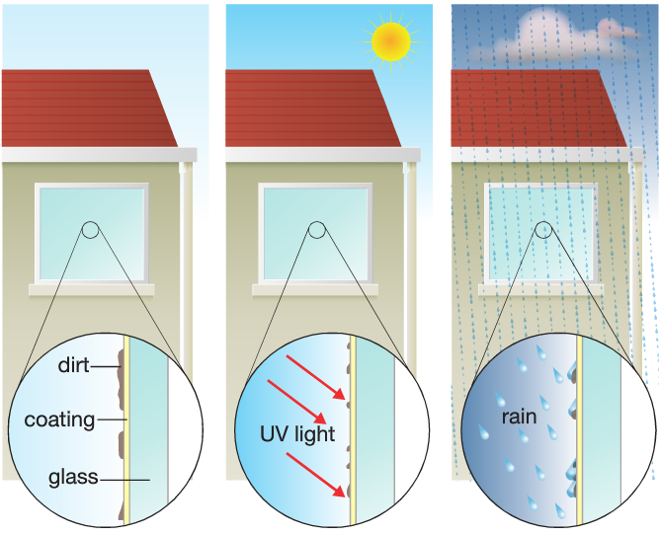
The British company Pilkington developed a self-cleaning glass Nanofabrics
using the opposite approach to making self-cleaning paint. Self-cleaning fabrics are coated with nanoparticles that
The glass is coated with titanium dioxide which in sunlight produce a rough surface of super-hydrophobic, water-
becomes electrically charged (called a photoelectric effect) repelling material.
The electric charges destroy materials in grease making them Nano-Tex fabric uses tiny ’whiskers’ of fabric to make the
water-soluble. This makes the glass surface hydrophilic, surface rough which causes water to wash off dirt in a
allowing the water to evenly wet the surface and then run off. Similar way to the lotus leaf. They are also stain resistant.

The Future of Nanotechnology
Carbon Nanotubes are nano-sized cylinders of carbon atoms that can join with each other to form flat sheets of hexagons. The properties of the carbon nanotubes depend on how the sheet is rolled. They are hundreds of times stronger than steel and are much lighter.
Possible uses include structures such as buildings cars, aircraft and in electronic devices.
Nanorobots are tiny devices that can get inside blood vessels and tissues to carry out a specific task, such as destroying cancer cells and performing complex surgery.
Scientists could construct a nano-motor by:
- Extracting the protein from bacteria membranes.
- Chemically sticking the protein to a silicon block.
- Chemically attaching a nickel rod to each protein.
Shape Memory Alloys
Shape memory alloys (SMAs) are metal alloys that change
shape as the temperature changes. They retain a ‘memory’
of the shape they were given when cold. If bent into a new
shape, they return to their original shape when heated.
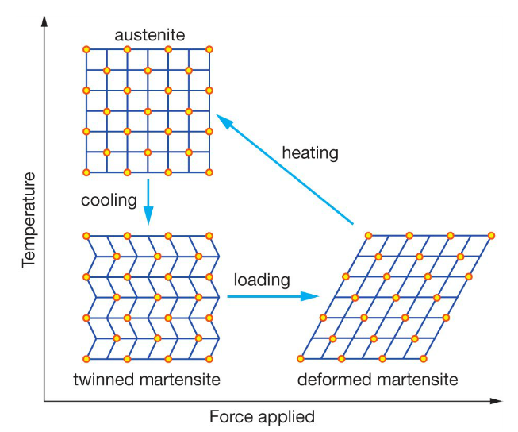
Nitinol is a shape memory alloy made of nickel and titanium.
The crystal structure
of Nitinol changes
with temperature
and how much force
is applied to it.
(refer to diagram)
Nitinol and other
shape memory alloys
are used in human
surgery eg. stents

