Name: _________________________ Teacher: _________________________
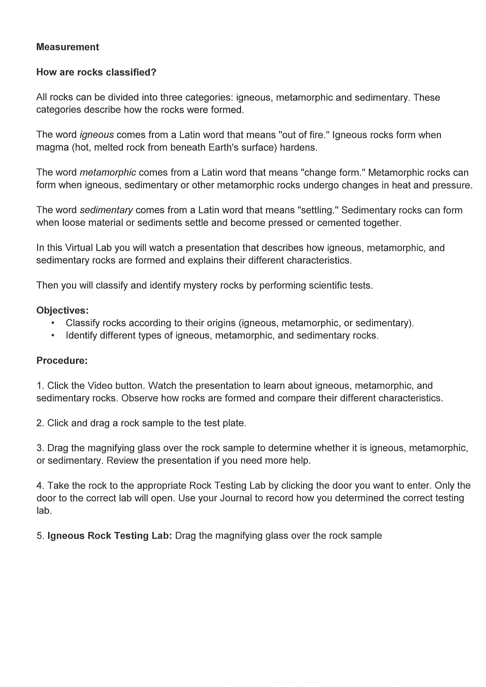
Virtual Lab: How are Rocks Classified?

http://www.glencoe.com/sites/common_assets/science/virtual_labs/ES04/ES04.html

r

(Refer to the Data Table shown on the back page)

8. Repeat the activity several times. Test at least one rock sample from each category and write your observations in the table below. After testing various rocks, complete the questions on the next page.

Table of Observations:
Sample | Observations | Proposed Name of Rock | Correct Name of Rock
Igneous Rocks:
Sample 1
Sample 2
Sample 3
Metamorphic Rocks:
Sample 1
Sample 2
Sample 3
Sedimentary Rocks:
Sample 1
Sample 2
Sample 3
Questions:
Q.1 For each rock sample you tested, how did you decide which testing lab to use?
________________________________________________________________________________________________________________________________________________________________________________________________________________________________________________________________________________________________________________________________________________________________________________________________________________________________________________________________________________________________________________________________________________________________________________________________________________________________________________________________
Q.2 How did you identify your rock samples?
________________________________________________________________________________________________________________________________________________________________________________________________________________________________________________________________________________________________________________________________________________________________________________________________________________________________________________________________________________________________________________________________________________________________________________________________________________________________________________________________
Q.3 When you find a rock on your own, what steps can you take to identify it?
________________________________________________________________________________________________________________________________________________________________________________________________________________________________________________________________________________________________________________________________________________________________________________________________________________________________________________________________________________________________________________________________________________________________________________________________________________________________________________________________
Draw a flowchart in the space below to illustrate the procedure.

Data Table: Characteristics of Rock Types

