Pregnancy is the time the foetus develops in the womb and usually lasts for around 9 months. A lot happens in this time.
Copulation
Copulation is the term for two individuals joining together for sexual reproduction.
- The penis is inserted into the vagina. Stimulation causes sperm to be squeezed out in a process called ejaculation.
- Several hundred million sperm are deposited near the cervix where they swim through the uterus to the fallopian tube.
- One sperm enters the egg and the surface of the egg changes to ensure that no more sperm can enter.
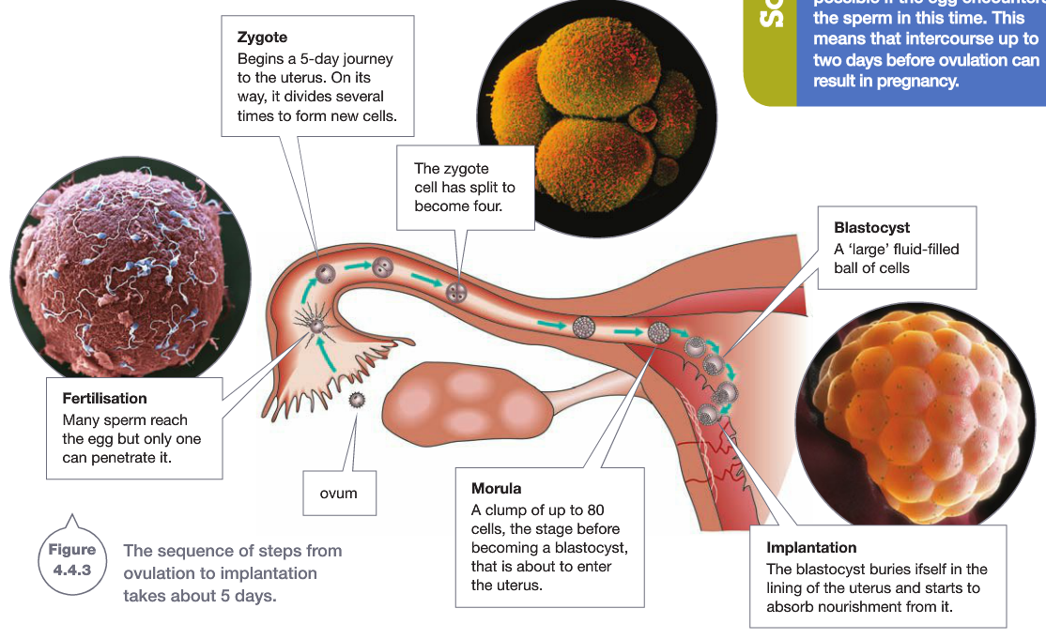
Implantation
When the egg is fertilised, the first cell of the new individual is called a zygote. The zygote begins to divide as it moves down the oviduct until it forms a hollow ball of cells called a blastocyst.
* About 5 days after fertilisation, the blastocyst reaches the uterus. The blastocyst then burrows into the cell wall in a process called implantation. The woman is now pregnant.

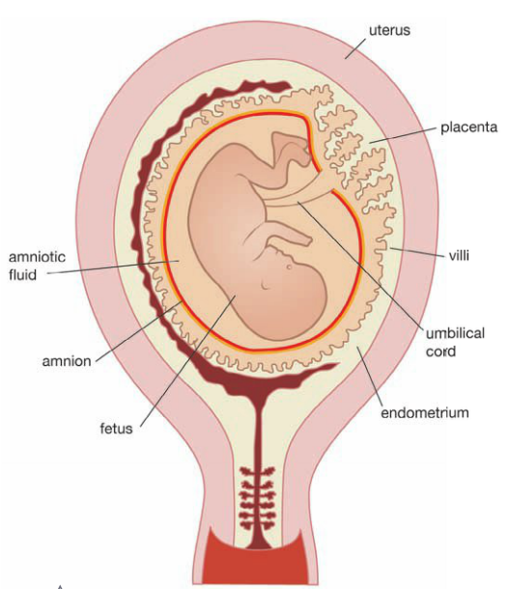
Embryonic Development
The baby takes about 38 weeks to develop from fertilisation to birth.
The first 8 weeks are called the embryonic period and the developing baby
is referred to as an embryo. During this time, all of the different types of cells
such as nerve, muscle and bone develop which form the different organs and
systems. In this critical period, the baby can be severely affected by such things
as smoking, alcohol, drugs and some illnesses such as rubella.
- Amniotic Fluid - acts as a shock absorber protecting the embryo
from bumps and keeps the embryo’s temperature constant.
- The Placenta - A highly folded series of membranes and blood vessels
that allow nutrients and oxygen from the mother to enter the baby,
and exchanges wastes such as carbon dioxide with the mother’s blood.
Foetal Development
Most organs and systems are formed by 9 weeks. The developing baby looks more human-like
and is classified as a foetus. The baby increases in size and the organs mature
During labour, the amniotic sac bursts and the cervix relaxes and widens to enable birth.

