Most water is not pure but is a mixture of H₂O and other chemicals. Examples:
- Seawater - H₂O, salt, sand, microscopic bacteria - large organisms, dissolved oxygen
- Water in rivers & lakes - H₂O, dirt, dissolved oxygen, fish, yabbies, bacteria etc.
- Swimming Pool water - H2O, dissolved chlorine, treatment chemicals
- Tap water - H2O, materials from rock & soil, water treatment chemical
Sources of Water:
1. Dams, lakes & Rivers - Contain materials from rocks & soil that include:
- Metals - magnesium, calcium, iron, copper, zinc
- Chemicals - chloride, fluoride, carbonate, nitrate
- Solid soil particles - clay, minerals, sand
- Living organisms - microscopic bacteria, algae, water snails, crustaceans (e.g. yabbies), fish
- Rubbish - household & industrial waste
- Toxic chemicals and pollutants from factories & drains
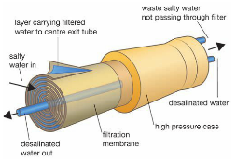
2. Groundwater - water below the ground from rainwater soaking into the rock layers known as aquifers
- water trapped by impervious rock underground is called
artesian water. The top layer is called the water table.
Where it reaches the surface it forms a lake or river.
- Desalination is the process of removing salts from water.
The most efficient method is Reverse Osmosis, which uses
a very fine membrane as a filter (as shown in the diagram)
Water Treatment
Water fit to drink is called potable water. The stages of water treatment are:
- Flocculation - separation of fine solid particles by adding flocculants (chemicals) that makes them form clumps
- Filtration - water is pumped through filters to remove the remaining particles
- Sterilization - chlorine is added to kill micro-organisms like bacteria
- Balancing pH - pH is a measure of acidity, and is adjusted so the water is not acid or alkaline (Neutral)
- Fluoridation - Fluoride is added to reduce the chance of tooth decay
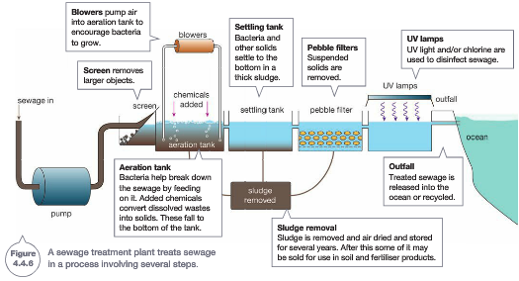
Sewage and Recycled Water Protecting our Water
Ways of conserving water:
* Reducing usage
* Avoiding toxic materials such as oils, fats, paints, medicines, pesticides from entering drains, gutters and waterways
* Reducing the use of detergents or using phosphate-free detergents

