A force is a push, a pull or a twist. Whenever there is a change in motion, a force has acted. A force can:
- Start something moving or speed it up. Acceleration is when something moves faster.
- Stop or slow down an objects motion. Deceleration is when something slows down.
- Cause an object to change direction.
- Change the shape of something.
Measuring Forces
A spring balance can be used to measure a force. The larger the force, the more the spring is stretched, and the higher the reading on the scale. Bathroom scales use a spring that is squashed or compressed to measure force.
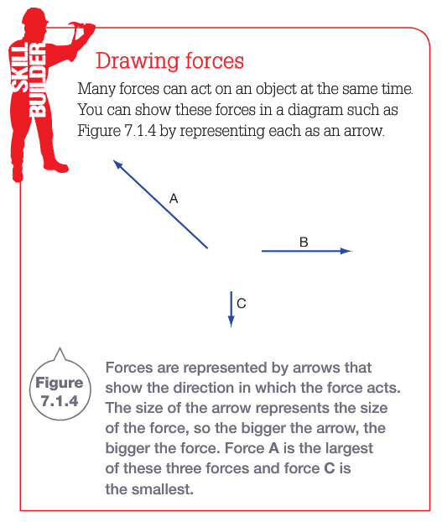
Force is measured in a unit called the newton (symbol N) – Named after Sir Isaac Newton. It takes about 1N to lift an apple.
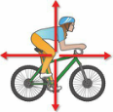
- Balanced Forces: The sum of all the forces acting on an object is zero.
The object does not speeds up, slows down ore changes direction.
* All of the forces
acting on the rider
are balanced as
indicated by the
arrows being the
same length.
driving force
friction
- Unbalanced Forces: The overall force acting on an object is not zero.
The motion of an object will change whenever forces are not balanced.
When the handlebars are turned, force acts on the bike causing it to change direction.

Inertia
Inertia is the tendency of an object to resist any change in motion. Newton’s first law of motion states that:
- Anything that is not moving will stay that way unless a force makes it move.
- Anything that is moving will keep moving at the same speed and in the same direction unless a force makes it change.
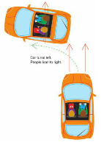
Friction between the tyres and the road acts on the car and overcomes its inertia.
This force does not act directly on the people. Inertia tends to keep them moving at the same speed and in the same direction.
Wearing seatbelts while travelling in a car and a helmet while riding a bike
help to protect you from the effects of inertia. In a front-on collision,
although the car has stopped, the motion of its passengers continues
at the same speed and direction.
Car turns left.
People lean to right
The Effect of Mass
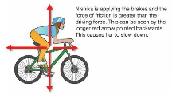
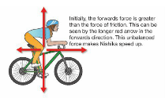
The more massive something is, the greater its inertia.
This means it takes a greater force to change its motion.
The force of friction is greater than the driving force. This causes the rider and bike to
slow down or come to a stop.
The forward force is greater than the force of friction. This causes the rider and bike to start moving or speed up.

