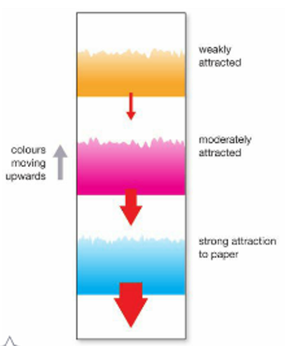
Methods for separating soluble substances from a mixture include:
- Chromatography
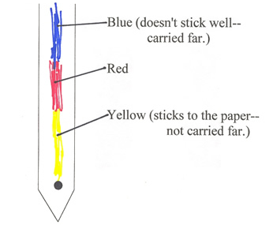
Chromatography is a process that can separate a mixture by making it move
through another substance like a paper strip (Refer to the diagrams)
How Paper Chromatography Works:
All of the chemicals in the Paper chromatography separates mixtures
mixture are attracted to the using a solvent (water) that carries a solute
paper by different amounts. (ink) up a strip of paper.
Substances that are strongly
attracted to the paper are
harder for the solvent to move
than substances that are weakly
attracted.
Chromatography is used to
identify the components of
mixtures such as oil and gas.
Paper chromatography
separates mixtures
- Evaporation
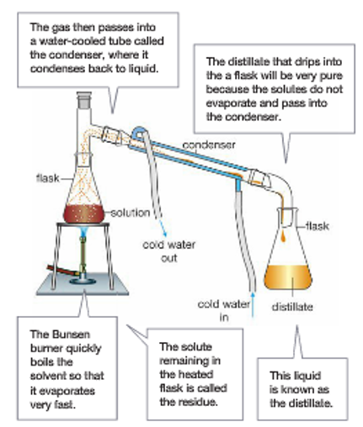
Evaporation is the process in which heat causes a liquid to change into a gas. Evaporation is also used in the laboratory to separate a solute from its solvent. The solute is left behind as a solid, and the solvent is lost to the atmosphere. This means that you can only collect the solute. The solute forms crystals in a process called crystallisation.
Liquids do not have to boil to evaporate. Evaporation
occurs at all temperatures above their freezing point.

- Distillation
Distillation uses both evaporation and condensation
to separate substances.
Evaporation - a liquid turns into a gas
Condensation - a gas cools to form a liquid
In distillation, the gas is condensed back into a liquid
so that it can be collected. The apparatus that converts
the gas back to a liquid is called a condenser.
(The diagram shows the laboratory apparatus)

Distillation is able to separate several liquids
if they have different boiling points.
- Adsorption
Adsorption uses substances such as carbon to separate
substances from water and air. The chemicals being
removed stick to the outside surface of another substance. Distillation using a Liebig condenser

If the substance has a huge surface area, a large amount of material can be adsorbed.

