Compounds are substances composed of two or more types of atoms (elements) combined in a fixed proportion by mass. Compounds have a unique set of characteristics that scientists call its properties.
- Some compounds are made up of molecules – such as water, wax and vegetable oil.
- Other compounds form crystal lattices. E.g. table salt – sodium and chlorine atoms; sand – silicon and oxygen.
Molecular Compounds
All the molecules in any compound are all identical in size, shape and number of atoms. The molecules of three common compounds are shown below. All of these compounds are made of just three elements – oxygen, hydrogen and carbon.
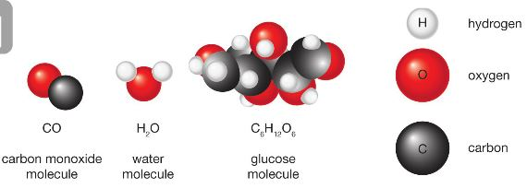
Molecular compounds are represented
by chemical formula:
Water – H₂O (2 x H atoms & one O atom)
Carbon dioxide – CO₂
Glucose – C₆H₁₂O_{6 The}
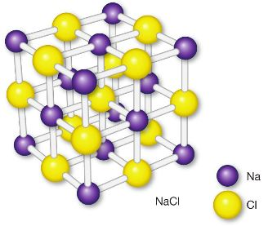
Compound Lattices
In crystal lattices, the atoms are very strongly bonded to each other
so they tend to be very hard at room temperature.
The lattice of table salt (sodium chloride) is shown in the diagram.
The chemical formula shows that table salt is made of sodium (Na)
and chlorine (Cl). NaCl is not a molecular formula since it does not
contain molecules. In a sodium chloride lattice, sodium and chlorine
atoms form a grid-like structure with one sodium atom for every
chlorine atom.
Mixtures
Any substance made up of two or more ingredients is a mixture. Examples include:
- Air is a mixture of the elements oxygen and nitrogen, and compounds such as water vapour and carbon dioxide.
- Tap water is not pure H₂O but a mixture including chlorine, fluorine and many other trace elements.
The main difference between a mixture and elements or compounds is that the molecules in a mixture are not identical. As a result, no chemical formula can be written for a mixture.
- Gaseous Mixtures - Any two gases can be mixed together because the particles of a gas are separated by
large distances. E.g. Air: 78% N₂, 21% O₂, 1 % CO₂
- Solid particles mixed with a gas are usually referred to as a smoke or dust.
- Liquid particles mixed into a gas are referred to as a mist or fog.
- Liquid Mixtures - Not all liquids can be mixed together. Liquids that can be mixed are said to be miscible.
Liquids that do not mix are said to be immiscible. E.g. oil and water
- When gases remain within a liquid as bubbles, the mixture is called a foam.
- A solid dissolved in a liquid is a solution. Undissolved solids form colloids or suspensions.
- Alloys - A mixture of a metal with other metals or non-metals. They often have very different properties
compared to the pure metal. E.g. steel harder than iron; stainless steel more resistant to rusting.

