Reducing Energy Consumption
- Most of the energy used to power cars, heat and cool homes, and run electric devices is produced from non-renewable sources such as coal, natural gas and oil.
- Non-renewable energy sources are limited in supply and burning them adds greenhouse gases to the atmosphere which increase the risk of global warming and may cause climate change.
- Ways of reducing energy consumption:
- Switch off lights, computers and televisions when not in use
- Walking, cycling or using public transport instead of relying on motor vehicles
- Replacing highly inefficient incandescent globes with more efficient compact fluorescent globes
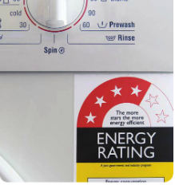
Energy Rating Labels
Energy efficient appliances save will save on energy usage and reduce
running costs. Large appliances carry a red and yellow energy rating label,
as shown in the diagram.
- Energy efficiency is shown by the number of stars. The more stars
shaded on the energy rating label, the greater the energy efficiency
of the appliance.
- The number on the label provides an estimate of the amount of
energy (in kilowatt hours per year) needed to operate the appliance.
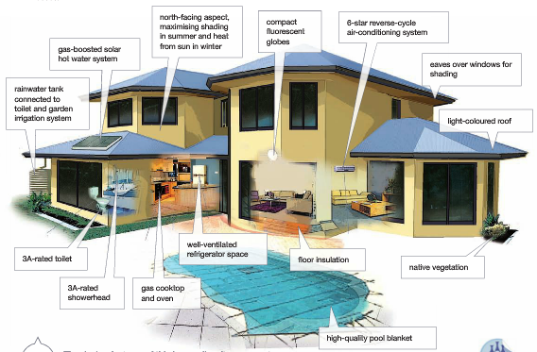
- The higher the number, the more energy is needed and the higher
the cost to run.
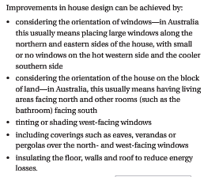
Efficient Housing

Innovative Design
Some ideas to increase energy efficiency include:
- Regenerative breaking - Kinetic energy as the car slows down is stored in a battery to power the car’s
electric motor when needed. Also used to save energy in lifts.
- Interior cooling in parked cars - Solar cells on a car roof powers an interior fan cooling the car when parked.
- Magnetic refrigeration - A new way of cooling using a magnetic field. -
- LED lighting - LED lights are very bright and use very little energy.
- Organic photovoltaics - New generation cheap, flexible solar cells made from carbon-based materials
- Dry washing machines - Currently being developed. Clean clothes using dirt absorbing beads.

