Simple machines change the size, direction or speed of a force to make a job easier. Levers, inclined planes (or ramps), wedges, screws, pulleys, wheels and gears are all simple machines.
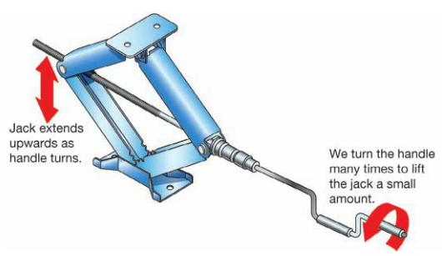
What can machines do?
To get a job done, you apply a force called an effort. The load is the force actually required to do the job.
A simple machine can make the task easier in three different ways. It can: Example: A Car Jack (force multiplier)
- Change the size of a force A small force is used to turn the
- Make things speed up jack handle through a very large
- Change the direction of a force distance, in order to lift the car.
- Changing the Size of a Force
Machines that multiply the force you apply to do a job
are known as force multipliers.
- Making Things Speed Up
Machines that make something move faster are known as speed multipliers. These are some examples:
- An Eggbeater - The blades move much faster than the handle.
- Gears on a bike - the different gear combinations can make the wheels spin much faster than the pedals.
3. Changing The Direction of a Force
A machine that changes the direction in which a force acts is called a pulley. Pulling downwards on a pulley cable
changes the direction of the force acting on an object which causes it to move upwards.
Levers
A lever is a simple machine that is made of a long, ridgid object and
a pivot or fulcrum about which it rotates. Most levers increase the
size of the effort that you can apply or reduce the effort needed.
Eg. A crowbar, using a hammer to pull a nail from wood,
Using a teaspoon to remove the lid of a coffee tin.
Mechanical Advantage
A machine’s mechanical advantage indicates how much easier it is to complete a task.
Mechanical advantage = load
effort
A machine with a mechanical advantage of 2 indicates that using this machine allows you to:
- Lift twice the load as normal
- Use twice the force as normal
For a lever, mechanical advantage can also be calculated using:
Mech. Advantage = dist. from effort to fulcrum
dist. From load to fulcrum
The two statements for mechanical advantage can be combined into a rule called the principle of levers. This states that:
Effort X distance = load X distance
(effort to fulcrum) (load to fulcrum)
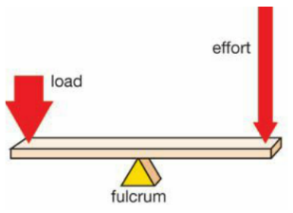
Types of Levers
Levers can be used as a force mulyiplier and as a speed multiplier.
The way a lever operates depends upon the position of the effort,
load and fulcrum.
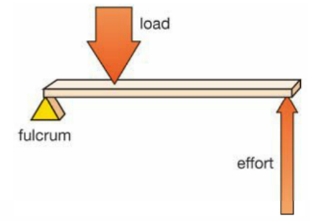
- First-class Levers
A crowbar ia a first-class lever.
The handle moves a larger distance,
but the force applied is increased.
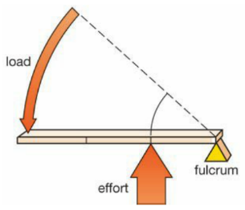
- Second-class Levers
A second-class lever has the load
positioned between the fulctim
and the effort. This acts as a force
multiplier. Eg. Wheelbarrow
- Third-class Levers
A third-class lever has the effort
positioned between the fulcrum
and the load. Eg. Cricket bat

