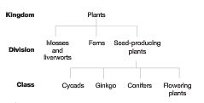
The plant kingdom has three divisions, characterised by the way they reproduce and whether or not they have organised systems of transporting materials through the plant. The diagram below shows these divisions and the plant classes:
Divisions:
- Mosses and Liverworts
- No tissue to transport water or nutrients
- Absorb water through their leaves.
- They reproduce by spores
- Ferns
- Have a vascular transport system
- They reproduce by spores
- Seed-producing plants
- Have a vascular system
- They reproduce using seeds
Seed-Producing Plants
Seeds are more complex than spores. There are also many other cells in the seed. These provide food for the developing
plant until the leaves are formed. The division of seed-producing plants has four classes:
- Cycads
Cycads have separate male and female plants. The male produces pollen in cones. The female cone produces the seed and provides some protection for the seed as it develops.
- Ginkgo
Ginkgo biloba is sometimes called the maidenhair fern tree. It is the only living member of this class. Ginkgos have separate male and female trees. Male trees produce pollen in cones, and female trees produce seeds in fruit with a fleshy, smelly coat.

- Conifers
Conifers produce male and female cones on the same tree. Male cones are pollen-bearing and female cones are seed-bearing. Cypress, fir and pine trees belong to this class. Australian conifers include:
Hoop pine, Huon pine and Wollemi pine.
- Flowering plants
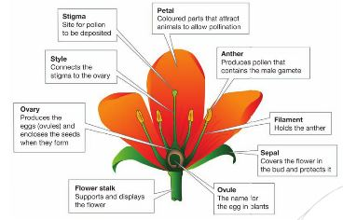
Flowering plants produce seeds fully protected in the female part of the flower. Many of the flowers attract pollinators such as bees, flies, moths, birds and bats.

Grasses with less showy flowers are pollinated by the wind.

Seed Structure:

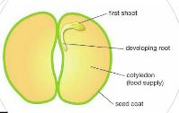
A flower is the reproductive structure

