A mixture is a substance made up of two or more pure substances or pure chemicals that have been stirred together.
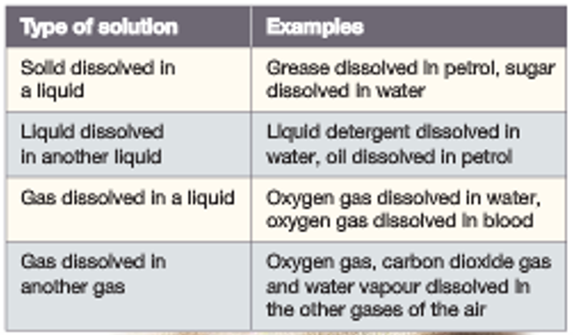
Solutions Table 1: Types of solution
- Soluble - A substance that dissolves in a liquid
- Insoluble - A substance that does not dissolve in a liquid
A solution is a mixture composed of one or more soluble substances
dissolved in a liquid e.g. Salt dissolved in water (Refer to Table 1))
Components of a solution:
- Solute - The substance that dissolves e.g. salt
- Solvent - The substance that dissolves the solute e.g. water
Problem:
If you dissolve 5 grams of sugar in
10 mL of water, what is the concentration?
Solution:
Concentration = mass = 5 = 0.5 g/L
volume 10

Concentration is a measure of the amount of solute dissolved
in a known amount of solvent. It is measured in grams per litre (g/L)
or grams per millilitre (g/mL)
- Concentrated - A large amount of solute in a small amount of solvent
- Dilute - A small amount of solute in a large amount of solvent
- Saturated - A solution that cannot dissolve any more solvent
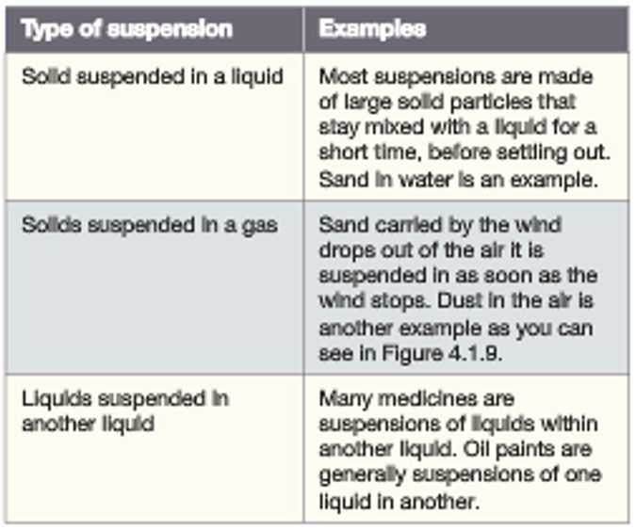
Suspensions Table 2: Types of suspension
A suspension is a mixture composed of one or more insoluble
substances and a liquid e.g. Sand and water (Refer Table 2)
Colloids
A colloid is a mixture made up of particles smaller than those found
in a suspension but bigger than those of a solute in a solution.
Types of colloid are summarised in Table 3, below.
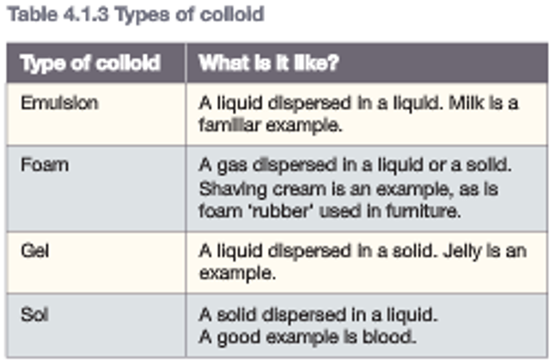
Table 3: Types of colloid

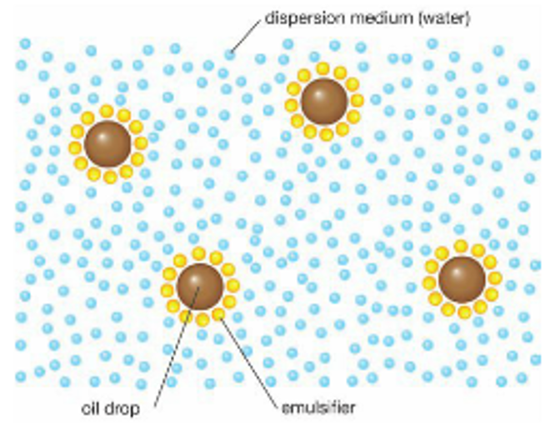
Emulsion Diagram: The emulsifier spreads the
oil droplets through the dispersion medium.

An emulsifier is a chemical that breaks up fats and oils into
small droplets and disperses it through the liquid.
(The diagram shows the emulsifiers surrounding oil droplets)
E.g. detergent, emulsifiers in milk

