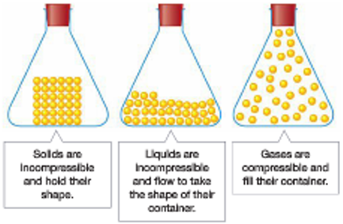
The particle model is a simplified representation of solids,
liquids and gases. It can explain some but not all of their properties.
The particle model assumes that all forms of matter are made up
of invisible, ball-like particles that are:
- Hard, incompressible and indivisible
- Attracted to each other
- Constantly moving
In solids, the attraction between particles binds them tightly
and rigidly together. Although the position of particles is fixed,
they vibrate on the spot, which increases with temperature.
In liquids, the particles are packed tightly together, which makes liquids incompressible. However, the particles in a liquid are not stuck rigidly to each other so liquids flow to take on the shape of their container. Particles in a liquid vibrate but can also move freely throughout the liquid. The particles move faster as the temperature increases.
In gases, the particles are not stuck to each other at all and there are large spaces between the gas particles. For this reason, gases are highly compressible. The particles are free to move anywhere within their container and move in straight lines until they collide with another gas particle or the side of the container. Gases always fill their container.
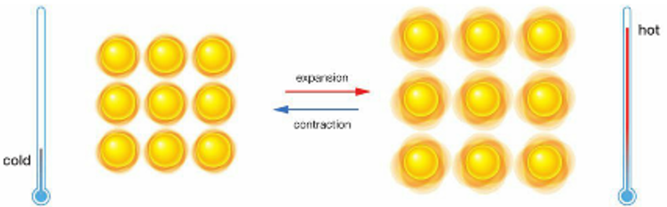
Expansion, Contraction and Pressure
Increasing the temperature causes the particles of solids and liquids to vibrate more. As a result, solids and liquids expand when heated and contract when cooled. Since the particles in liquids are free to move, liquids expand and contract more than solids.

As the temperature of a gas increases the particles travel faster. This means they hit the sides of the container more frequently and with more force. If the container is flexible then increasing the temperature causes it to expand. If the container is rigid, then heating the container will increase the pressure inside the container. The reverse is true.

Melting and Freezing
Increasing the temperature of a solid gives its particles enough energy to overcome their attraction and they form a liquid. Increasing in temperature of liquid particles gives them further energy to overcome attractions forming a gas.
Evaporation occurs when particles at the surface of a liquid have enough energy to escape and form a gas.

Solutions and the Particle Model
When a solute dissolves, its particles are spread evenly through the solvent. The particles are too small to be seen.
Diffusion occurs when the particles of two gasses or liquids mix evenly (or diffuse) without stirring.

